Alternatives to PowerPoint:

Prezi:
Prezi is a nifty alternative to PowerPoint that provides one large canvas for student’s to display information. Then, you program the camera to zoom and spin around that canvas in interesting ways.
Head to www.Prezi.com to see it in action.

Infographics:
Infographics are becoming increasingly important in terms of digital media. They are aesthetically pleasing ways of displaying different kinds of info.
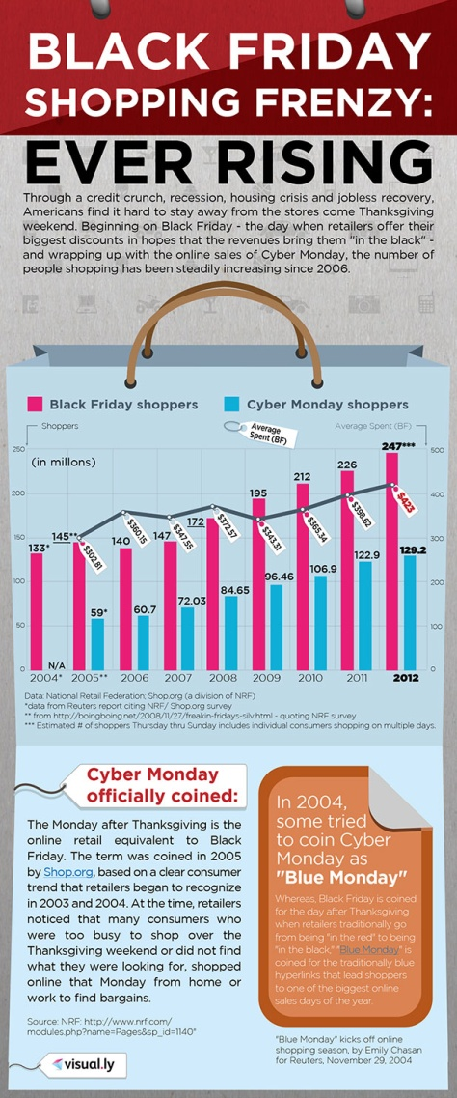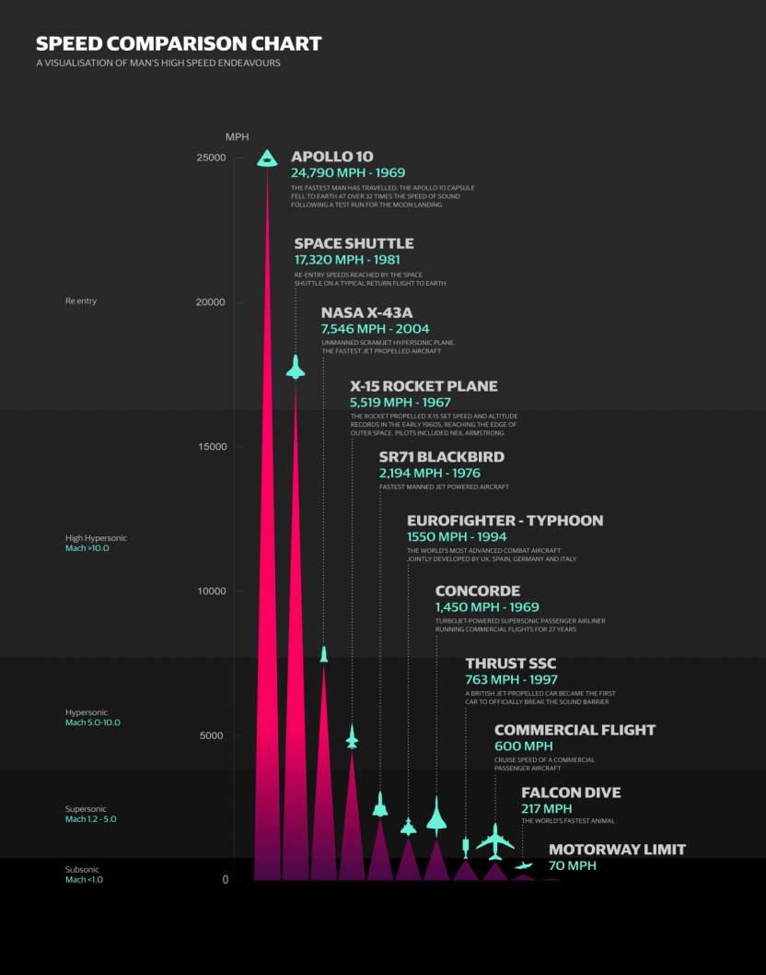

Sites to create infographics:
- www.visual.ly
- http://infogr.am/
- http://beta.mural.ly/
- Many others revealed by Google search

Animation:
Students can use several different sites to create their own cartoons. These easy to use tools are great for re-creating scenes from a story, summarizing a historical event, or demonstrating scientific principles.

- www.xtranormal.com
- Animoto.com
- Goanimate4schools.com

3D Renders:
The 9th grade students in our class have learned a lot about creating 3D models using a program called SketchUp. It allows student to create three-dimensional models of buildings, objects, and land formations. Below is actual student work:
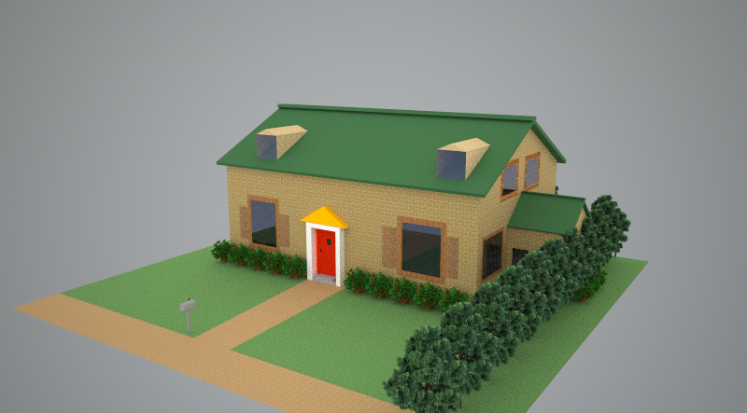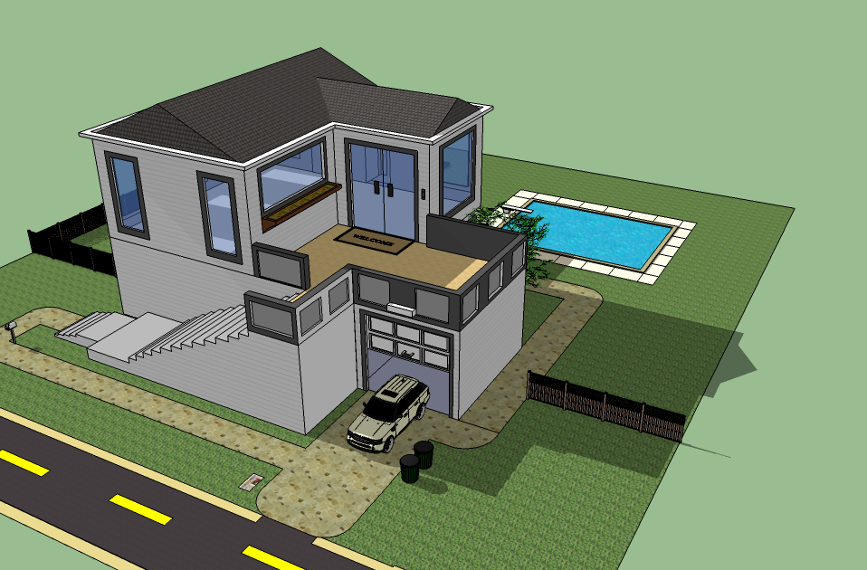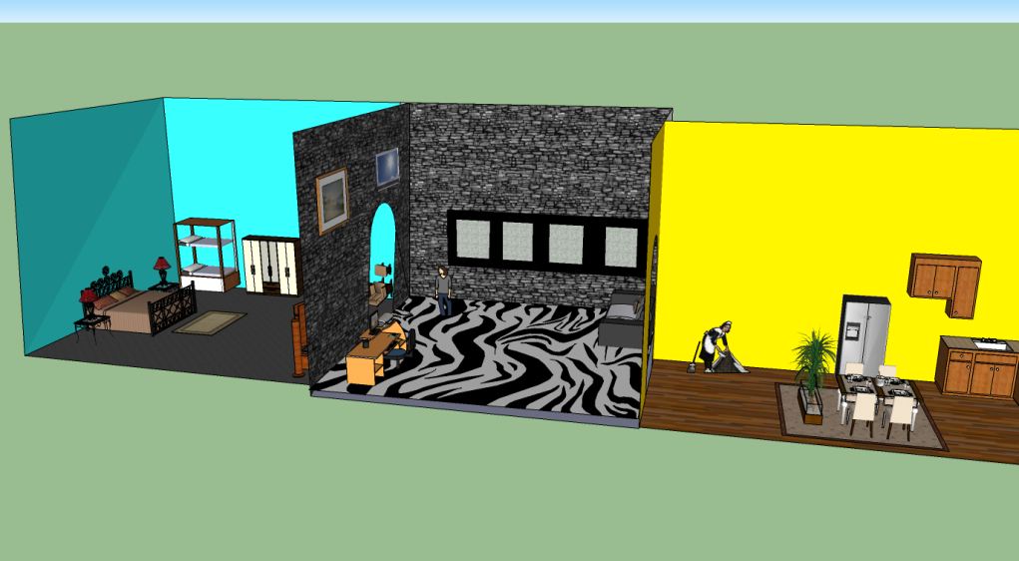

Google Earth:
Using Google Earth, students can create custom tours of important locations, adding text and pictures as they zoom around the globe.
Here’s a screen shot from a Google Lit. Trip about Virgil’s Aeneid.
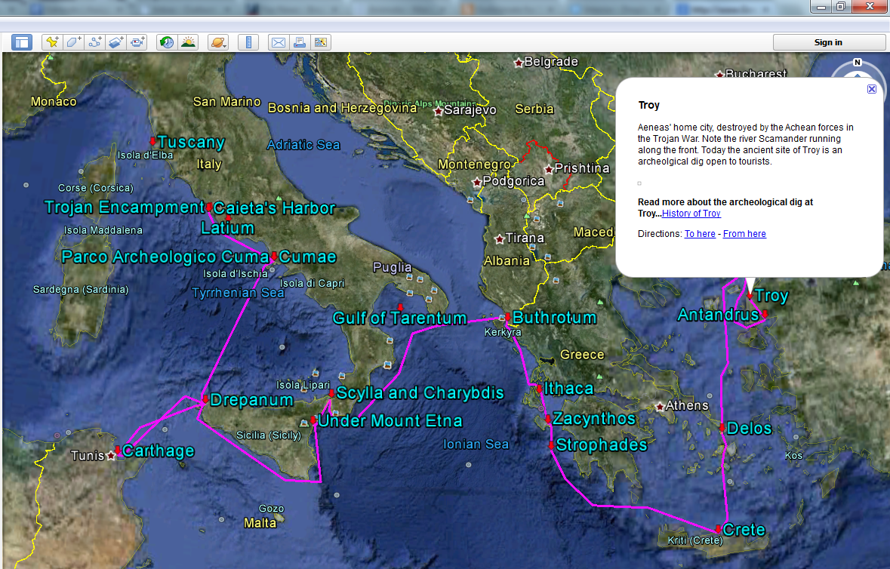

Check out http://www.googlelittrips.org/ for many more examples.
Misc. Digital Storytelling Tools:
- http://www.meograph.com
- www.Zooburst.com
- www.Storybird.com
- http://www.carnegielibrary.org/kids/storymaker/
- http://www.storyjumper.com/
- http://www.storyjumper.com/

iMovie:
Many of our wonderful 10th grade teachers have already experimented with iMovie with the students and their laptops. The program is fairly easy-to-learn. With a little tinkering, our students have had a lot of success. YouTube is full of helpful tutorials. Mr. Eames, although he is not an expert, is also a potential resource.

For questions, contact Mr. Eames at jeames@seedschoolmd.org

